6th February, 2020

Bangalore

From,

Darshana Jeyakumar

Reg No:17M5681

6th Term, MBBS,

VIMS & RC, Bangalore

To,

The Principal

VIMS & RC, Bangalore

Respected Sir,

Subject: Requisition to Approve our Community Medicine Project for 2020-Reg

I, Darshana Jeyakumar studying in 6th term MBBS, VIMS & RC, representing a team consisting of Chaitanya G (17M5673) , Chaithanya P Reddy (17M5674) , Chandana Ch (17M5675), Chandana P(17M5676), Chandana T (17M5677), Chandini Gundala (17M5678), Deepa Choudhary(17M5682), Dega Nethra Reddy (17M5683) , Dharshini Swaminathan (17M5684) , Dinesh Kumar (17M5685), Dravid M C (17M5686) , Ranjana K (17M5846) , Sai Karuna G (17M5848).

We would like to undertake a project titled “Assessment of Depression, Quality of life and Comorbidities among elderly” under the guidance of Dr. Shilpa, Assistant Professor, Department of Community Medicine at Vydehi Institute of Medical Sciences and Research Centre. I am enclosing the protocol for ethical clearance.

We kindly request you to approve and forward our proposal to the ethical committee

Thanking you,

Yours sincerely, Darshana.Jeyakumar

**Assessment of Depression, Quality of life and Comorbidities among Elderly**

Names of the contributors:

* Chaitanya G (17M5673), 6th term MBBS , VIMS & RC
* Chaithanya P Reddy (17M5674), 6th term MBBS, VIMS & RC
* Chandana Ch ( 17M5675 ), 6th term MBBS, VIMS & RC
* Chandana P ( 17M5676) , 6th term MBBS, VIMS & RC
* Chandana T ( 17M5677) , 6th term MBBS, VIMS & RC
* Chandini Gundala (17M5678) , 6th term MBBS, VIMS & RC
* Darshana Jeyakumar (17M5681) , 6th term MBBS, VIMS & RC
* Deepa Choudhary (17M5682) , 6th term MBBS, VIMS & RC
* Dega Nethra Reddy ( 17M5683) , 6th term MBBS ,VIMS & RC
* Dharshini Swaminathan (17M5684) , 6th term MBBS, VIMS & RC
* Dinesh Kumar K ( 17M5685) , 6th term MBBS, VIMS & RC
* Dravid M C ( 17M5686) , 6th term MBBS, VIMS & RC
* Ranjana K ( 17M5846) , 6th term MBBS ,VIMS & RC
* Sai Karuna G (17M5848) , 6th term MBBS, VIMS & RC

Name of the guide: **Dr. Shilpa**

Assistant professor,

Department of Community Medicine,

VIMS & RC

**Introduction:**

Depression is a common illness worldwide with more than 264 million people affected1.   WHO, has predicted that by 2020 depression will become the third leading cause of disability worldwide2. Late life depression (LLD) is a disorder occurring in individuals older than 603. Ageing results from the impact of the accumulation of a wide variety of molecular and cellular damage over time1. This leads to a gradual decrease in physical and mental capacity, a growing risk of disease and ultimately death1. In older adults, the symptoms of depression may be overlooked because they are assumed to be due to concurrent medical illnesses4. India being labelled “an ageing nation” with 7.7% of its population being more than 60 years is the most depressed country in the world, followed by China and the USA5.

A major factor in the context of evaluating depression in the elderly is the role of medical problems6. With aging there is a rapid increase in the prevalence of a number of medical disorders, including Parkinson's disease, hypertension, diabetes mellitus, coronary heart disease, chronic kidney failure, benign hypertrophy of prostate, stroke, arthritis and malignancy7. We evaluate medical comorbidity as a risk factor for depression. Thereby it becomes highly essential and complex to manage both depression and medical comorbidities in elderly together, and many a times, it becomes a clinical challenge to the practitioners8. The growing knowledge of clinical complexity introduced by the comorbidity of late life depression can guide the development of comprehensive treatment models9.

The WHO defines Quality Of Life (QOL) as an individual's perception of their position in life in the context of the culture and value systems in which they live and in relation to their goals, expectations, standards and concerns10. The rapid urbanization and societal modernization has brought in its wake a breakdown in family values and the framework of family support, economic insecurity, social isolation, and elderly abuse leading to a host of psychological illnesses11. Many surveys have shown that retired elderly people are confronted with the problems of financial insecurity and loneliness12,13. Quality of life in old age is of a new sensitivity in health and social order, it is considered a problem and challenge for society14.

According to the World Health Organization, QoL corresponds to the “individual perception of his position in life in the context of his culture and value system he lives, and in relation to his goals, expectations, standards and concerns”15.

**Objectives:**

1. To describe the socio-demographic characteristics of study subjects.

2. To estimate the magnitude of depression among study subjects.

3. To identify the co-morbid conditions among study subjects.

4. To assess the quality of life.

5. To find out the association between the Quality of Life and depression.

**Review of Literature:**

A study by Pooja Chauhan on prevalence and correlates of depression among elderly population of rural South India revealed that 9.3% of the elderly had depression . Depression was found to be significantly associated with increasing age , co-morbid condition, economic dependence and physical dependence for daily activities.

A study by Krithika on Nutritional status and associated co-morbidities among the elderly in Doiwala block, Dehradun revealed that out of total 192 elderly (>60 years) interviwed, 48.4% where males and 51.6% were females. The men weight(KG) was 54.65±13.44(25-94) and mean BMI(Kg/m2) was 22.30±5.08(12.57-44.64) . BMI analysis showed that 21.8% were malnourished, 15.4% were overweight and 7.4% were obese. Comorbidities were found to be more in malnourished group as compared to the well nourished.

A study by Manoj Kumar on Comparitive study of prevalence of Depression and Associated Risk Factors among the Elderly Population revealed that majority of the subjects included in study had Mild depresssioon(38.6%) and least (4.05%) of the elderly were severly depressed. Male and female were equally distributed and majority were married (59.6%), and lived in a joint set up of family(81.6%). Majority were literate(67.9%) and financially not independent. Only association between type of family, education and financial dependency with depression was found to be statically significant.

**Materials and Methodology:**

1. **Place of study:** Vydehi Institute of Medical Sciences and Research Centre, Whitefield.

2. **Study design:** Convenient sampling

3. **Study population:** All individuals aged above sixty years.

4. **Study period:** Three to Four months

5. **Inclusion criteria:**

* All elderly (60 years and above).
* Those willing to participate.

6. **Exclusion criteria:**

* Seriously ill patients & comatose patients.
* Patients who have difficulty in communication.

7. **Sample size:**

n=Z2pq/d2

Z=1.96 at 95% confidence interval

p = prevalence of depression among elderly (9.3%)

q=1-p

d= precision(5%)

n= (1.96)2 (0.093) (0.907)/ (0.05)2

n= 130

8. **Data collection:**  A predesigned & pre structured questionnaire will be used to collect data of socio-demographic variables like age, gender, religion, educational status, occupation, marital status, living status, type of family.Data like financial dependence, dietary habits, social interaction, personal habits, utilization of health service and co-morbid conditions will also be collected. Study subjects will be subjected to measurement of Blood pressure, Weight, Height and BMI.

**Measurement of height**

For the measurement of height, study subjects were made to remove the footwear and stand with heels together and toes apart and head positioned so that the line of vision was perpendicular to the body (Frankfurt line) against the wall. The arms were hung freely by the sides, the head, back, buttock and heels in contact with the wall. A wooden scale was brought down to the topmost point on the head and marking was made on the wall. Measurement was taken using measuring tape in centimeters (cm). Height was recorded to nearest 0.5 cm.

**Measurement of weight**

The weight was measured in kilograms (kg) using standardized bathroom weighing machine with the study subject standing erect on centre of platform, with the body weight evenly distributed between both the feet together and toes apart without footwear with accepted clothing and looking straight ahead. The weight was recorded to nearest 0.5 kg.

**Body Mass Index (BMI)**

In this study, BMI classification proposed by the WHO Western Pacific Regional Office in collaboration with IOTF (International Obesity Task Force) steering committee (2000) for Asian people was used. It is also called as Quetlet index and was used to assess obesity and is computed by

**BMI=Weight (in kg) / Height (in metre2)**

It is classified as BMI <18.5 (Under weight), 18.5-22.9 (Normal), 23.0-24.9(At

risk obesity), 25.0-29.9 (Obese I) and > 30 (Obese II).

Informed written consent will be taken. Confidentiality of the study subjects will be maintained. The questionnaire will be explained to the patient and the answer given by them will be recorded. Data will be collected using interview technique.

The questionnaire used will be Geriatric Depression Scale -15(GDS).

**Geriatric Depression Scale (GDS)**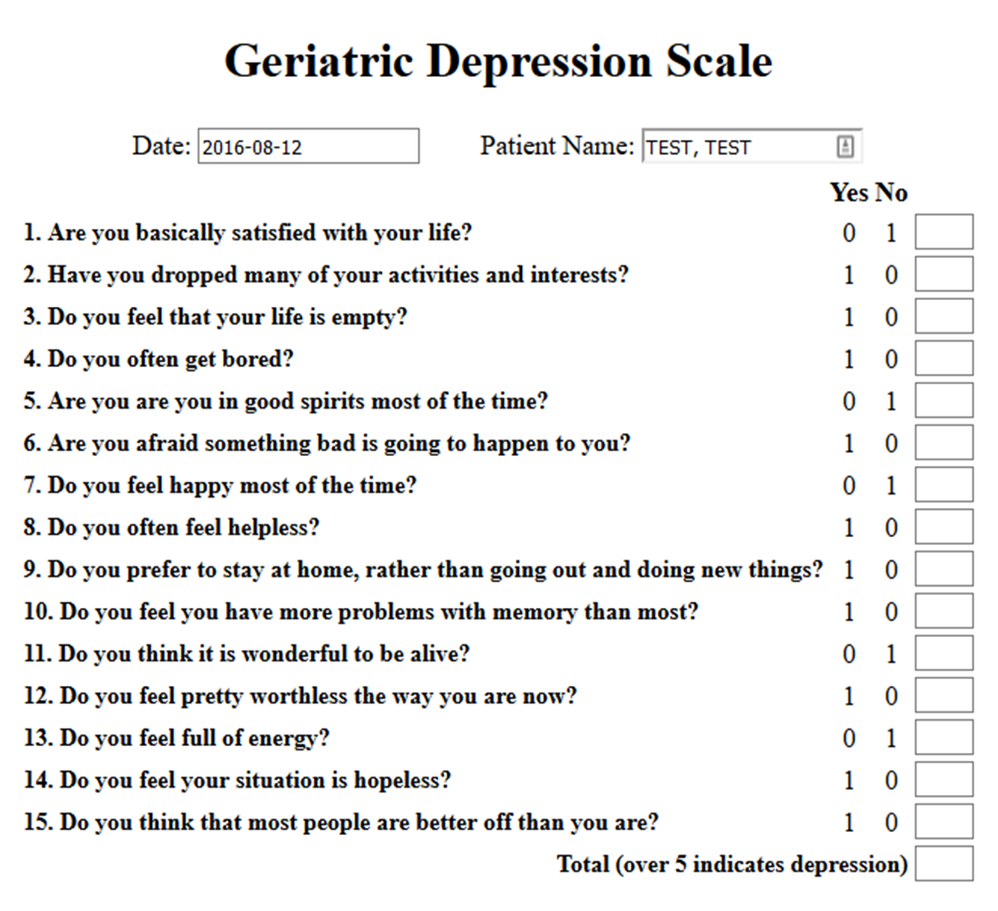

TOTAL SCORE:

|  |  |  |
| --- | --- | --- |
| Score | Grading | Score of given subject |
| 0-4 | Normal |  |
| 5-8 | Mild depression |  |
| 9-11 | Moderate depression |  |
| 12-15 | Severe depression |  |

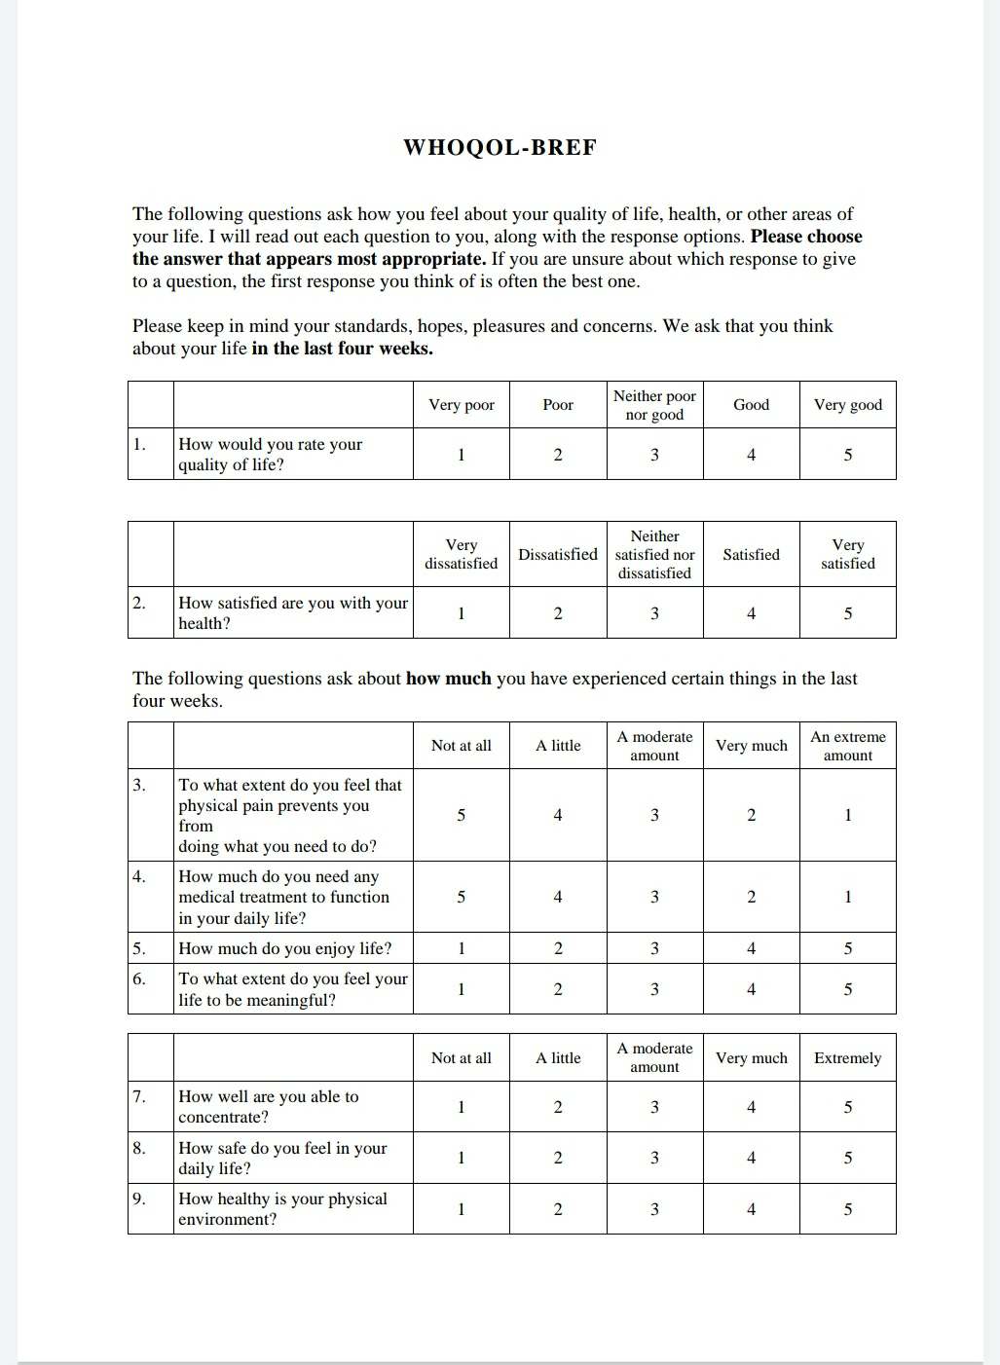**WHO Quality of Life Scale**

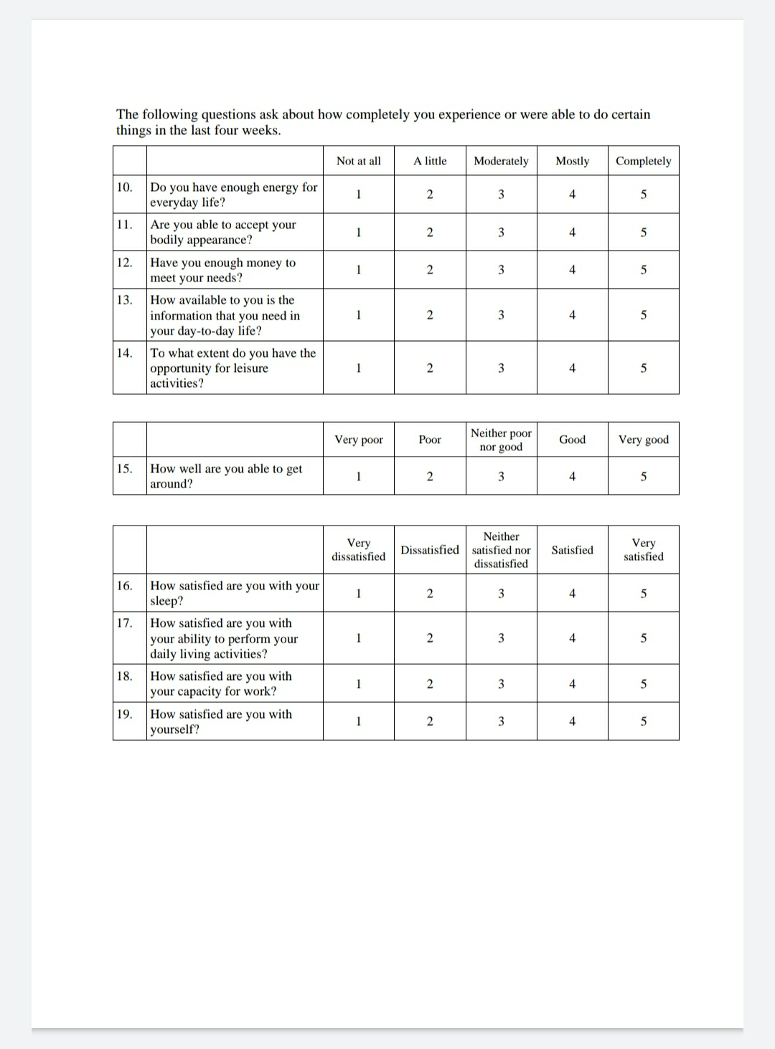

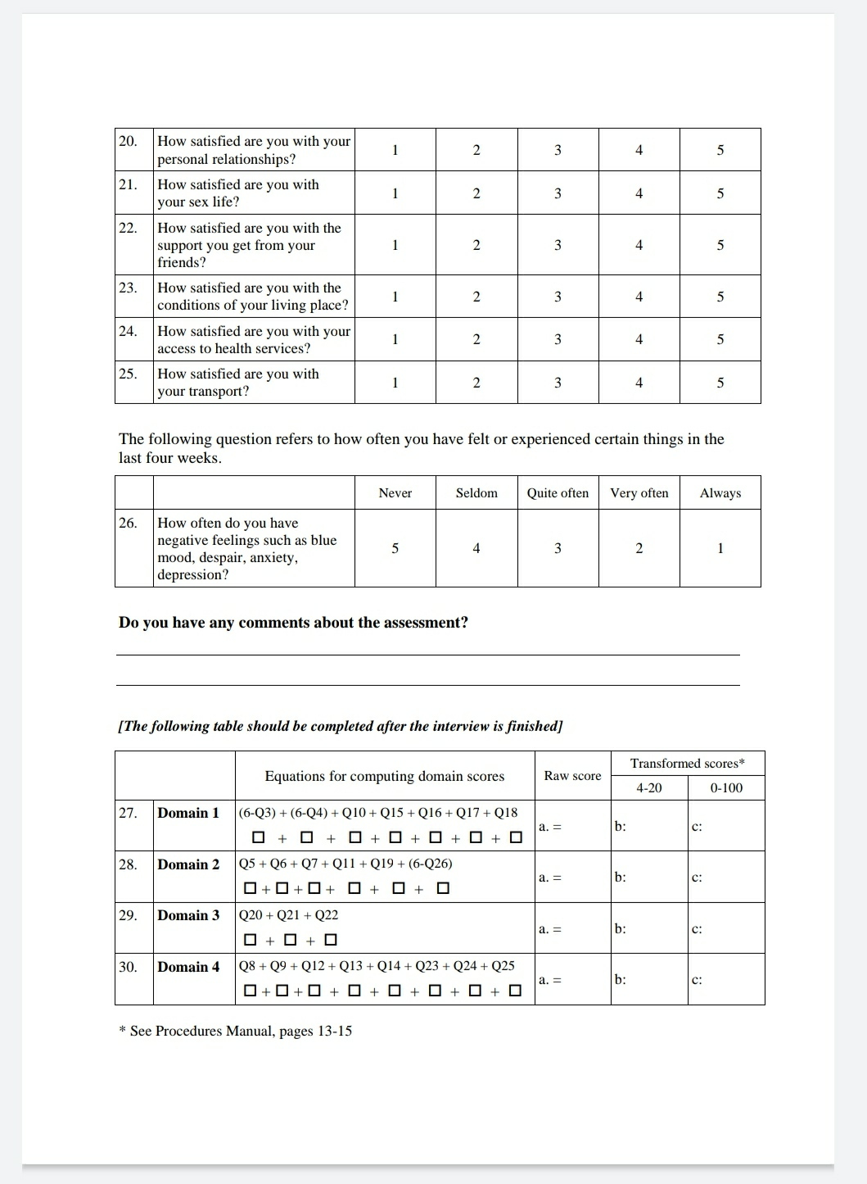

9. **Statistical analysis:**

* Descriptive statistics like Mean and Standard Deviation were used.
* Independent sample t test or Mann Whitney U test will be performed to compare QOL with depression status

Proforma No.- Date:

Starting time:

Ending time:

Duration:

**PROFORMA**

**Socio-Demographic Characteristics**

1. **Name :** ___________________________________________
2. **Postal Address :** ____________________________________ ____________________________________ ____________________________________

**Phone Number/Mobile**: ___________________________

1. **Age** (Years): ________________
2. **Sex:** 1. Male 2. Female 
3. **Religion:** 1. Hindu 2. Christian 

3. Muslim 4. Others (specify):_________

1. **Educational status:**

1. Illiterate 2. Just literate 

3. Primary education 4. Secondary education 

5. High school education 6. Pre- university 

7. Diploma / Degree 8. Post Graduate degree

1. **Occupation:**

A] **Previous occupation:**

1. Professional 2. Government Service 

3. Private Service 4. Business 

5. Agriculture 6. Labour 

7. House wife 8. Others (specify) _______________

B] **Present occupation:** 1. Unemployed 2. Employed

C] **If employed** (specify) __________________

D] **If unemployed: Reason** 

1. **Marital status:**

1. Married 2. Unmarried 

3. Divorced 4. Separated 

5. Widower/ Widow 

1. **A] Living status:**

1. Living alone 2. Living with spouse 

3. Living with spouse and children 4. Living with children

5. Living with relatives 6. Others

B] **Type of family**:

1. Nuclear family 2. Joint family

3. Three generation family

1. A] **Financial dependence:**

1. Independent 2. Partially dependent

3. Dependent 

B] **If Dependent**:

1. Family members 2. Relatives

3. Friends 4. Others (specify) 

1. A] **Among dependent, are they getting any financial assistance:**

1. Yes 2. No

B] **If yes,**

1. Old age pension from govt 2. Retirement pension

3. Interest on saving/ deposits 4. Others (specify) 

1. A] **Do you hold any property in your name**

1. Yes 2. No

B] **If yes**,

1. Movable property 2. Immovable property

1. A] **Do you have any debts**

1. Yes 2. No

B] **If yes,**

1. For construction 2. For health

3. For social occasion 4. Others (specify) 

1. **Are you involved in decision making in any of the family affairs**

1. Yes 2. No

**SOCIAL CHARACTERISTICS**

1. A] **Social Interactions**:

1. Yes 2. No

B] **If yes, with**

1. Family members 2. Friends

3. Relatives 4. Others (specify)

C] **Like to visit social occasion/ social gathering:**

1. Yes 2. No 

D] **If yes,**

1. Marriages 2. Religious functions

3. Political gathering 4. Others (specify)

E] **If no,**

1. Have health problem 2. Family members does not allow 

3. Not interested 4. Others (specify)

1. A] **Was there any events in the past 12 months:**

1. Yes 2. No

B] **If yes,**

1. Change of accommodation 2. Death 

3. Divorce 4. Separation

1. A] **Are you satisfied by the way you are treated by your family members and relatives**

1. Yes 2. No

B] **If no,**

1. Not giving food 2. Not giving clothing

3. Not giving money for medicines 4. Not allowing for social gathering

5. Others( specify)

**LIFE STYLE AND PERSONAL CHARACTERISTICS**

1. **Dietary habits**:

A] **Type of diet**:

1 .Vegetarian 2.Non vegetarian 

B] **Is your appetite good**

1. Yes 2. No 

C] **If No**

1. Indigestion 2. Does not feel like having

3. Others( specify) 

D] **How many meals do you have per day**?

1. <Two meals 2. >Two meals 

E] **Usually with whom do you have meals at home**?

1. Alone 2.With family members 

3.Others (specify) _____________

1. A] **Are you getting adequate sleep**

1. Yes 2. No

B] **If No,**

1. Difficulty in getting sleep 2. Getting up in-between the sleep

3. Getting up early 4. Others( specify)

1. **Personal Habits:**

|  |  |  |  |  |  |  |  |  |  |  |
| --- | --- | --- | --- | --- | --- | --- | --- | --- | --- | --- |
| Sl.no | Type | Previous  (Yes/No) | Present  (Yes/No) | Frequency* | | | | | | Duration  (in years) |
| D | W3 | W2 | W1 | FN | O |
| 20.1 | Alcohol |  |  |  |  |  |  |  |  |  |
| 20.2 | Smoking |  |  |  |  |  |  |  |  |  |
| 20.3 | Tobacco chewing |  |  |  |  |  |  |  |  |  |
| 20.4 | snuff |  |  |  |  |  |  |  |  |  |

*D: Daily, W3: Thrice a week, W2: Twice a week, W1: Once a week, FN: Once in fortnight,

O .Occasionally

**COMORBID CONDITIONS**

1. **Are you suffering from any disease**? 1. Yes 2. No 

**If Yes**

|  |  |  |  |  |  |  |  |  |  |
| --- | --- | --- | --- | --- | --- | --- | --- | --- | --- |
| **Sl. no** | **Disease** | **Duration**  **(months/yrs)** | **Treatment history** | | | | | **Family history**  **(yes/No)** | **Relationship** |
| **Allopathy** | **Ayurveda** | **Homeopathy** | **Unani** | **Others** |
| 1. |  |  |  |  |  |  |  |  |  |
| 2. |  |  |  |  |  |  |  |  |  |
| 3. |  |  |  |  |  |  |  |  |  |
| 4. |  |  |  |  |  |  |  |  |  |
| 5. |  |  |  |  |  |  |  |  |  |

**UTILIZATION OF HEALTH SERVICES**

1. **How many times you have visited clinic/Hospital in past 6 month? ____________**
2. **How many times you have been referred to specialist in past 1year? ___________**
3. **How many times you have been hospitalized in past one year? ________________**

**Geriatric Depression Scale (GDS)**

TOTAL SCORE:

|  |  |  |
| --- | --- | --- |
| Score | Grading | Score of given subject |
| 0-4 | Normal |  |
| 5-8 | Mild depression |  |
| 9-11 | Moderate depression |  |
| 12-15 | Severe depression |  |

**WHO Quality of Life Scale**





**References:**

1. Ageing and health. World Health Organization. 2018 February 5.

Available from: <https://www.who.int/news-room/fact-sheets/detail/ageing-and-health>

1. Sivertsen H, Hanevold G, Engedal K, Selbaek G and Helvik A. Depression and and Quality of life in older persons: A Review. Dementia and Geriatr cognitive disorders 2015 Sept 12; 40: 311-339.
2. Blackburn P , Wilkins-Ho M and Wiese B. Depression in older adults: Diagnosis and management. BC Medical Journal 2017 April; 59(3): 171-177.

Available from: https://www.bcmj.org/articles/depression-older-adults-diagnosis-and- management

1. Park M and Unützer J. Geriatr Depression in Primary Care. PMC 2012 Jun 1.

Available from: <https://www.ncbi.nlm.nih.gov/pmc/articles/PMC3184156/>

1. Rajan S. Demography of ageing. In: Dey AB, editor. Ageing in India, Situational analysis and planning for the future. New Delhi: Rakmo Press; 2003. [Google Scholar]
2. Luber P, S Meyers B, Williams-Russo G , James P, Tara N. Depression and service utilisation in elderly primary care patients. Am J of Geriatr Psychiatry 2001;9(2):169-176.
3. Grower S, Avasthi A. Prevalence of physical comorbidity and prescription patterns in elderly patients with depression: a multicentric study under the aegis of IAGMH. J Geriatr Ment Health 2018;5(2):107-114
4. V Lala S, Sahatovic M. Medical and Psychiatric comorbidities among elderly individuals with bipolar disorder: a literature review. J Geriatr Psychiatry and Neurology 2012;25(1):20-
5. Alexopoulos GS. Comorbidity of late life depression: an option for research on mechanisms and treatment. Biol Psychiatry 2002 Sept 15;52(6):543-558
6. Mosalem FA, Mahfouz EM, Fattah MA, Hassan EE. Quality of life (QOL) among geriatric rural population - El-Minia - Egypt. El-Minia Med 2009;20(1):1-15.
7. Kartikeyan S, Pedhambkar BS, Jape MR. Social security the Global Scenario. In J Occup Health. 1999; 42:91–98.
8. Bhatia HS. Ageing and society: A sociological study of retired public servants. Udaipur: Arya's Book Centr Publishers 1983.
9. Goel PK, Garg SK, Singh JV, Bhatnagar M, Chopra H, Bajpai SK. Unmet needs of the elderly in a rural population of Meerut. In JCM 1999;28:165–166.
10. Fleck MPA, Louzada S, Xavier M, Chachamovich E, Vieira G, Santos L. Rev. Saúde Pública 2000; 34(2): 178-183.

Available from: <http://dx.doi.org/10.1590/S0034-89102000000200012>

1. Mikaelly A, Pontes M, Farias M, A Monteiro E, Silva C, R Periera R. Quality of Life and Depressive Symptoms in the Elderly Living in Community. iMedPub J 2015;8(246):2-8.

**CONSENT FORM**

INFORMED CONSENT

**Vydehi Institute of Medical Sciences and Research Centre**

**#82,EPIP Area,Whitefield,Bangalore,Karnataka-560066**

This informed consent form is for elderly people above 60 years of age Vydehi Institute of Medical Sciences and Research Centre, Whitefield, whom we are inviting to participate in the study about depression, quality of life and comorbidities among elderly people.

**Part 1: Information Sheet**

**Study Title::** “Magnitude and Assessment of depression, quality of life and comorbidities among elderly”

**Introduction:**

Before you agree to participate in this study, it is of vital importance that you go through this document and understand the implications of your answers. This document describes the purpose, risks and precautions of this study.

In order to obtain optimum results for our study, it is important that you are quite truthful while answering this questionnaire.

We are going to give you information and invite you to be part of this research. Before you decide whether you want to take part, you can talk to anyone you feel comfortable with about the research.

This consent form may contain words that you do not understand. Please ask us to stop as we go through the information and we will take time to explain. If you have questions later, you can ask them to any of the researchers.

**Purpose of the study:**

This project is being conducted in order to assess the magnitude of depression, quality of life and to identify comorbid condition among elderly people. Conducting this study will help us to find the association between the quality of life and socio-demographic variables.

**Type of Research Intervention:**

An interviewer-administered questionnaire will be provided after which the details of the patient will be recorded in a case report form.

**Participant Selection:**

You are being asked to participate in this study, as you meet the selection criteria for this study.

**Voluntary Participation:**

Your participation in this research is entirely voluntary. It is your choice whether to participate or not. If you choose not to participate, it will have no consequences. You may change your mind later and stop participating even if you agreed earlier.

**Procedure:**

* Study Design; Cross sectional study
* Methodology for data collection;

1. Permission from the college principal and ethics committee is taken.
2. Questionnaires will be distributed. Height, weight and biological parameters will be recorded. The researchers shall be present while study participants answer questions, in order to answer any queries.
3. If you do not wish to answer any of the questions included in the survey, you may skip them and move on to the next question.
4. The information recorded is confidential, your name is not being included on the forms
5. The questionnaires are then collected back from the participants.

**Risks:**

There is a risk that you may share some personal or confidential information by chance, or that you may feel uncomfortable talking about some of the topics. However, we do not wish for this to happen. You do not have to answer any question or take part in the survey if you feel the question(s) are too personal or if talking about them makes you uncomfortable.

**Benefits:**

There is no direct benefit to the participant as such, but the study will benefit the researchers in determining the co-relation between long working hours and depression and job satisfaction.

**Reimbursement:**

You will not be provided any incentive to take part in the research.

**Confidentiality:**

The research team will maintain the confidentiality of data with respect to both information about the participant and information that the participant shares. There will be no disclosure of data except to statistician and amongst the researchers.

**APPROVAL:**

This study has been (approved) by the ethics review board of Vydehi Institute of Medical Sciences and Research Centre. A written approval has been (granted) by the committee.

**Part 2: Certificate of Consent**

I have been invited to participate in research about the impact of long working hours on depression and job satisfaction.

I have read the foregoing information, or it has been read to me. I have had the opportunity to ask questions about it and any questions I have been asked have been answered to my satisfaction. I consent voluntarily to be a participant in this study .

Print Name of Participant__________________

Signature of Participant ___________________

Date ___________________________

Day/month/year

**Investigators Statement:**

The participant signing this consent form has fully understood the study and is well informed about the study as well.

I confirm that the participant was given an opportunity to ask questions about the study, and all the questions asked by the participant have been answered correctly and to the best of my ability. I confirm that the individual has not been coerced into giving consent, and the consent has been given freely and voluntarily.

A copy of this ICF has been provided to the participant.

Print Name of Researcher/person taking the consent________________________

Signature of Researcher /person taking the consent__________________________

Date ___________________________

Day/month/year